Final Project

Ryan Manchanthasouk

Southern New Hampshire University

April 28th, 2019

Final Project

The first task was to insert new data elements in to the table. To do that, the INSERT INTO query is used. 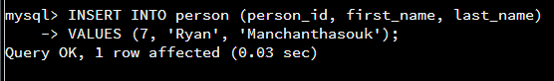

Here, the table is being altered to add another column for additional information using the ALTER TABLE query.

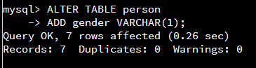

Now that there is a new column, the UPDATE query is used to update a column in one of the rows in the table.

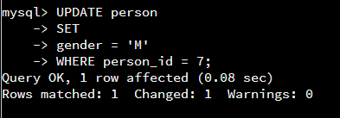

The next prompt was to delete the record from the “person” table where the first name was “Diana” and last name was “Taurasi.” The DELETE FROM query was used, specifying the person_id rather than the first_name or last_name for functionality.

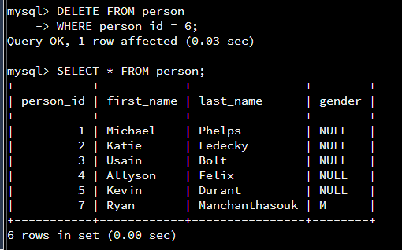

The ALTER TABLE query is used again to add another column “favorite” in to the contact_list table.

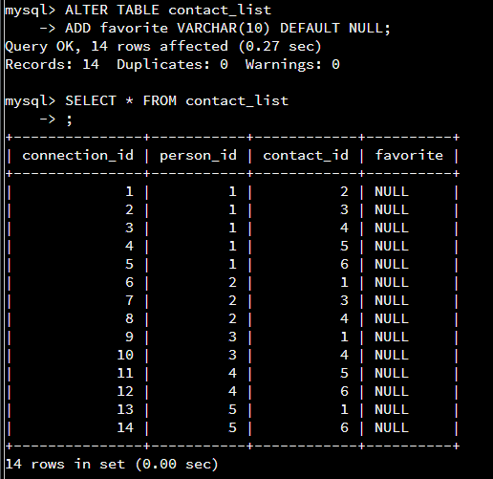

The next two screen shots show that value is added to the new column for all of the individuals in the table.

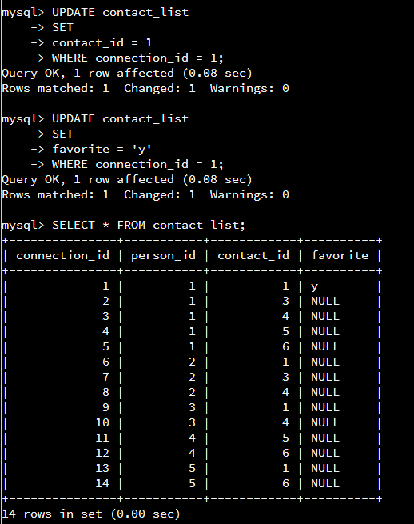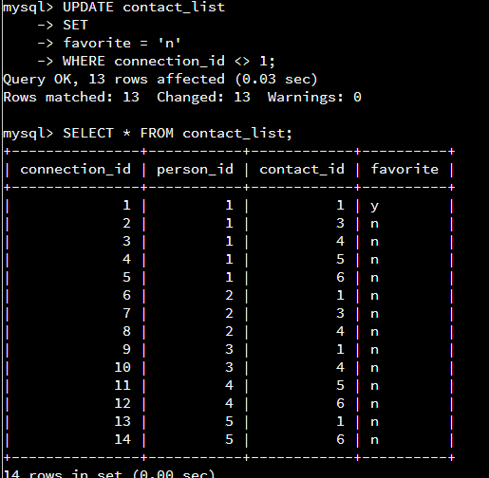

The next step was to create a table called “image,” where the CREATE TABLE query is used. The same query is used to create the message_image table.

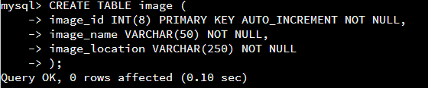

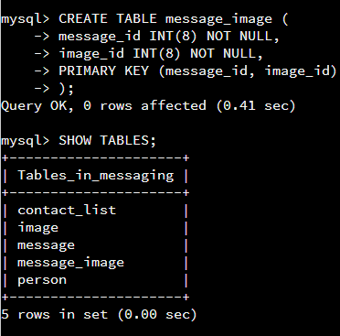

The INSERT INTO query is then used again to insert data values in to the image table.

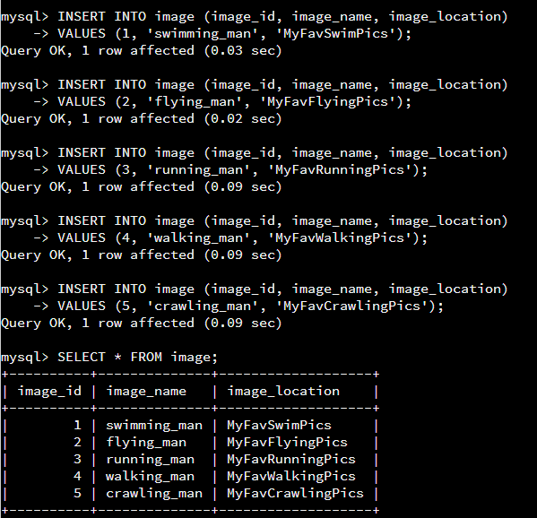

Additional data elements are also inserted into the message_image, using data elements from existing data tables.

